|  |  |
| --- | --- |
| **Solar Panel** | |
|  | **4** |

|  |  |  |  |  |  |  |
| --- | --- | --- | --- | --- | --- | --- |
| **PARTS** | Base Plate  http://images.studica.com/images/product/fischertechnik/86grundplatte.jpgx1 | mySTEM Board  mySTEM™ Project Board for NI myDAQx1 | NI myDAQ  NI myDAQ for Secondary Schoolsx1 | DC Motor  32293: S-MOTOR 6-9V x1 | Photo Resistor  32698: PHOTO RESISTOR LDR 03 x2 | Ball Lamp  37869: BALL LAMPx2 |
| Limit Switch  37783: MINI-SWITCHx2 | Bottom plate 30 X 90  32859: BOTTOM PLATE 30 X 90 RED x1 | Block 30  32880: BUILDING BLOCK 30 WITH BORE x2 | Angle Girder 30  36920: ANGLE GIRDER 30 BLACK x1 | Mounting Plate  38245: MOUNTING PLATE WITH PEG 15 X 90 RED x1 | Block 15  32881: BUILDING BLOCK 15 x2 |
| Gearbox  31078: MOTOR REDUCING GEARBOX BLACK x1 | Winch Drum  31016: WINCH DRUM x1 | Mini Mote Axle  31063: MINI MOTE AXLE 60 x1 |  |  |  |

|  |
| --- |
| Assemble |

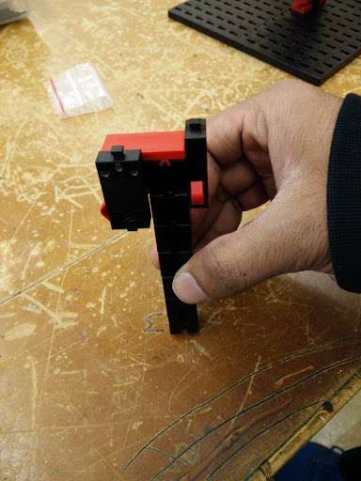

**Attach two limit switches to the post and use a building block attach the pieces**

**Using 4 block 30 and one block 15 make one post**

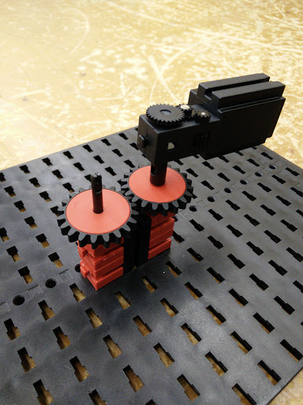

**Attach two gears onto a drive shaft and on one setup a motor with a gear box**

**Attach two bore block to one block 30 either side with the bore facing up**

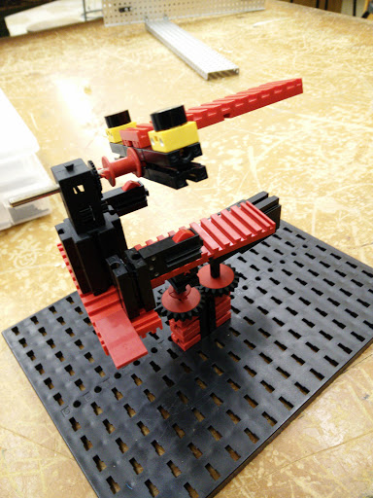

**Attach two plates on either side for limit switches**

**Using a coupler attach the drive shaft to make a turn table base and for the panel**

**Make two post with a block 30 and a limit switch**

**Using a motor and gear box make a rotatable panel**

**Using three building block 30 and one building make a panel with a photocell on either side**

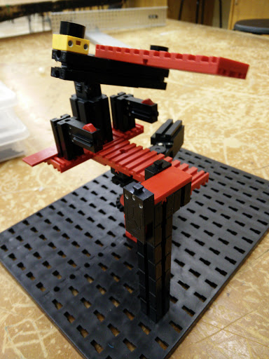

**With the limit switch tower and motor connected to the base your model should look like this**

|  |
| --- |
| Wiring |

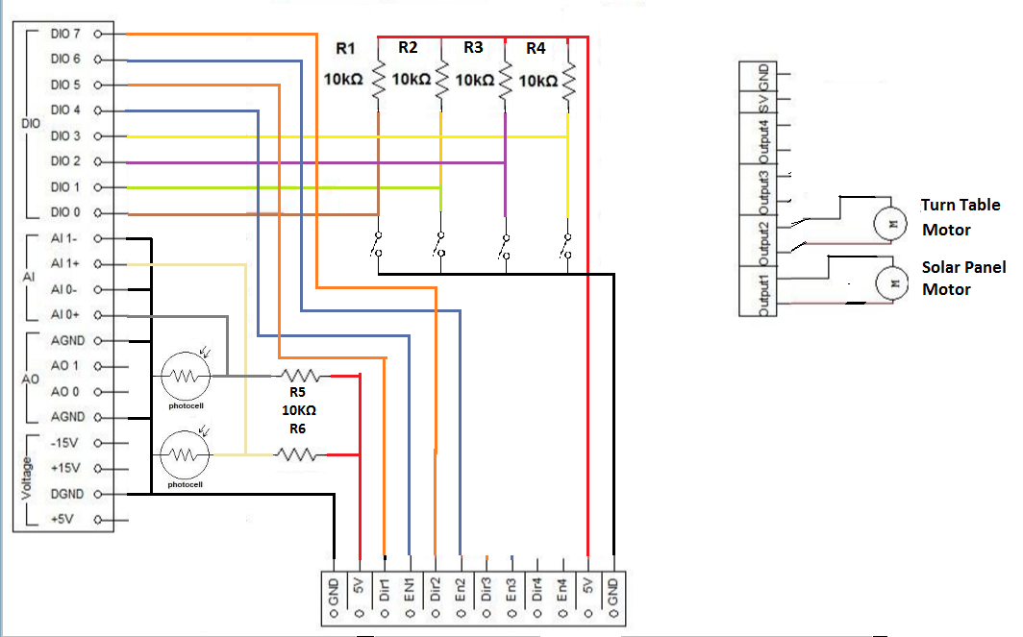

|  |
| --- |
| Program |

Before beginning, take a look at the flowchart below to understand the process and logic behind the Solar Panel program.

G:\Downloads\Solar Panel - LabView (1).png

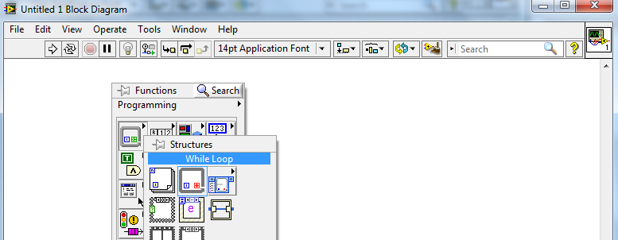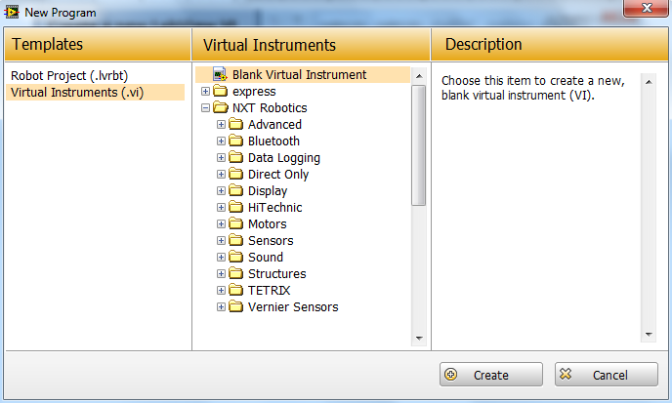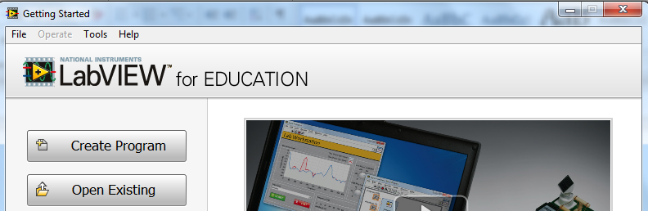

**The block diagram and front panel windows will appear. From the block diagram, right click to open Functions pallet. Go to Structures.**

**Select While Loop**

**Click Create**

**Choose Blank Virtual Instrument**

**Create a new LabView VI**

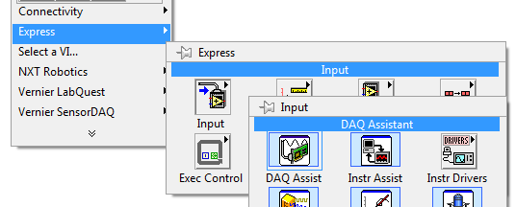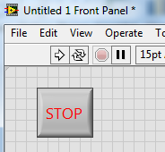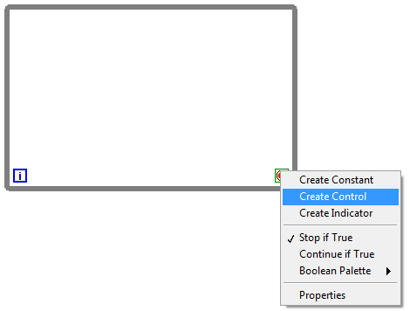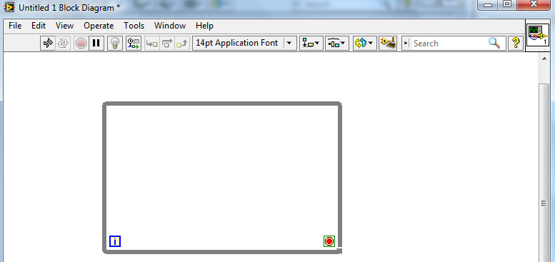

**Select Create Control**

**Right click on the Loop Condition**

**Stop Button will appear on the front panel window. Resize / Style it as you seem fit.**

**You can drag the borders to change the size as you need**

**Select DAQ Assistant**

**Choose Input**

**Open Functions pallet and go to Express**

**Drag mouse to create the while loop**

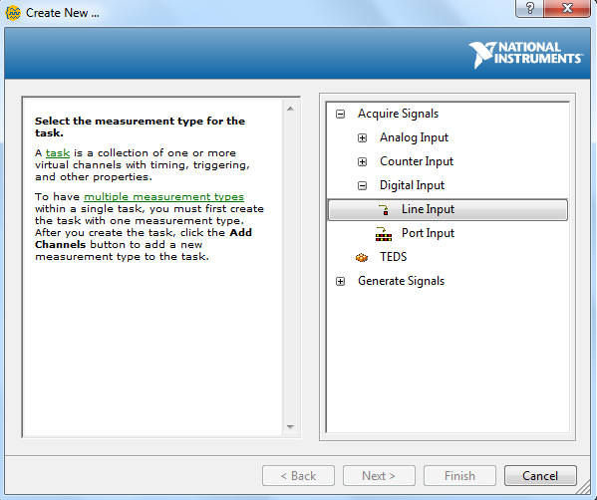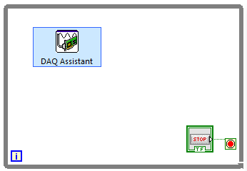

**Select Line Input**

**Choose Digital Input**

**Place DAQ Assistant inside the while loop**

**At this point, make sure that the NI myDAQ device is connected to your computer before proceeding**

**A DAQ Assistant window will appear. Click on Acquire Signals**

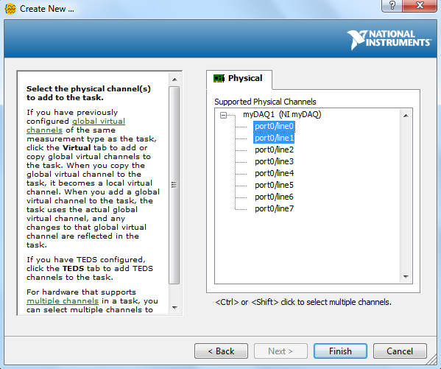

**Select Ports 0 and 1 using the Ctrl Key**

**Your NI device will appear in the list**

**Click Finish**

**If your DAQ device doesn’t appear in the list, make sure to connect it to the computer via a USB. Then close the DAQ window and re-follow the steps to create the DAQ Assistant**

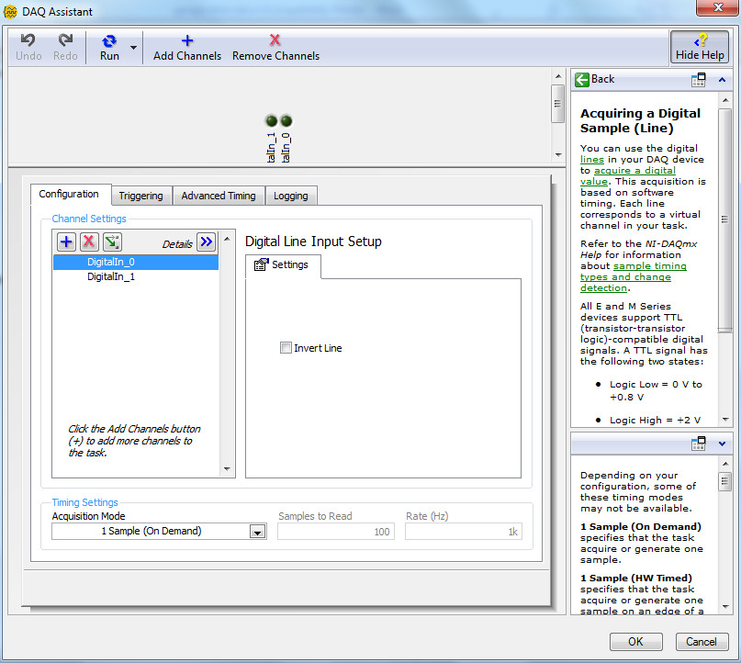

**It is possible to change the speed or rate at which the input is read. Leave it as it is for now.**

**Click OK to finalize the settings**

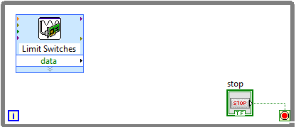

**Double-click to rename the DAQ Assistant to specify its purpose**

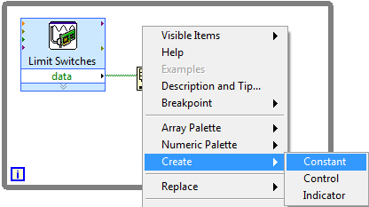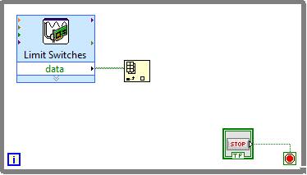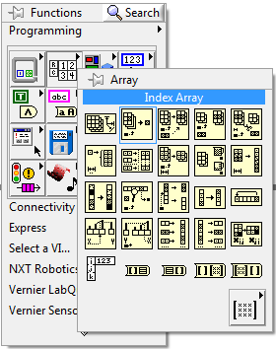

**Connect the data terminal of DAQ Assistant to array terminal of Index Array**

**Create an Index Array**

**Open Functions pallet and go to Array**

**Select Constant**

**Click on Create**

**Right click on the index terminal of Index Array**

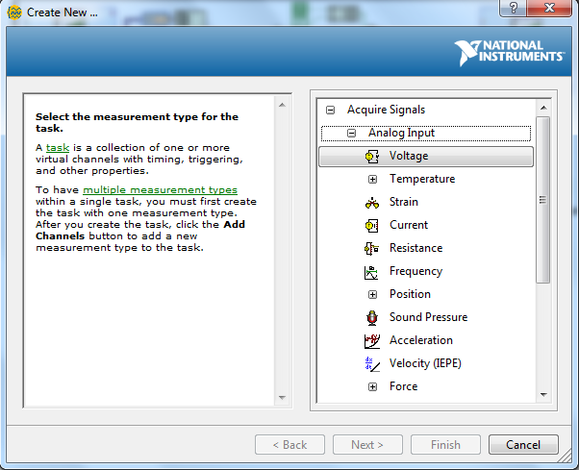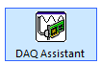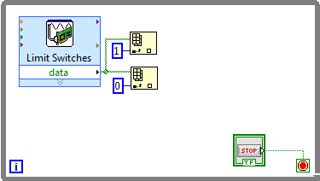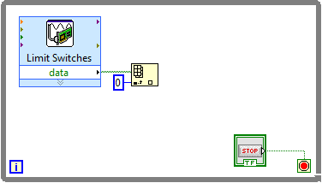

**Select Voltage**

**Choose Analog Input**

**From the DAQ Assistant window, choose Acquire Signals**

**Create another DAQ Assistant from the Functions pallet.**

**Give the constant a value of 1**

**Create another Index Array and connect it in the same way**

**Give the constant a value of 0**

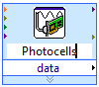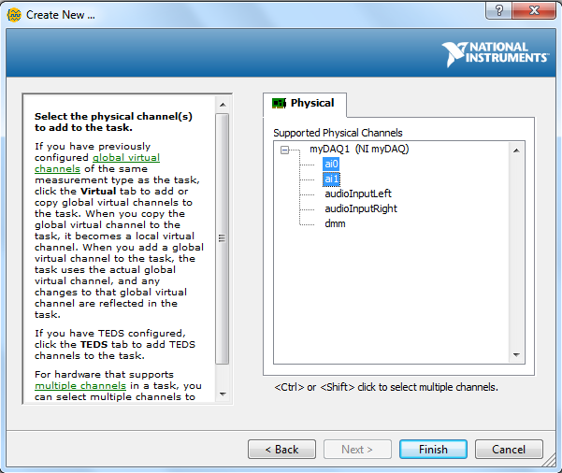

**Select Ports 0 and 1 using the Ctrl key**

**Rename the DAQ Assistant to specify its purpose**

**Click Finish**

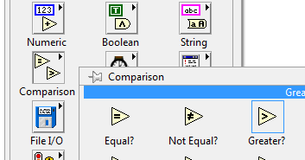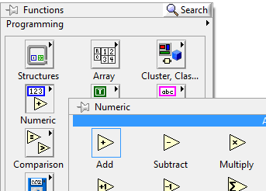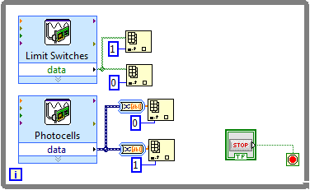

**Create a Greater?**

**Go to Comparison from the Functions pallet**

**Create a Add**

**Go to Numeric from the Functions pallet**

**Connect it to two Index Arrays with constants 0 and 1**

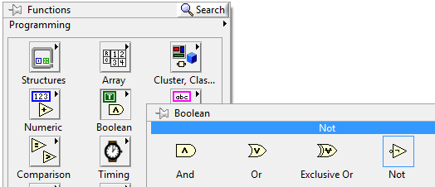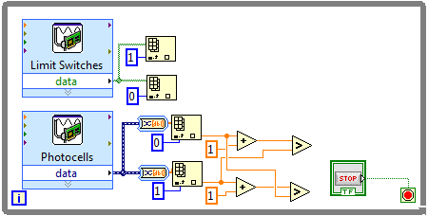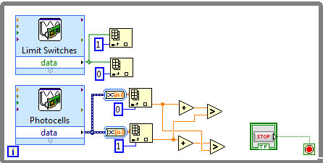

**Create a Not**

**Create a And**

**Go to Boolean from the Functions pallet.**

**Right click on the y terminal of the two Add blocks and create a constant of 1 for each**

**Create two Add blocks and two Greater? Blocks and connect them to the Index Arrays as shown**

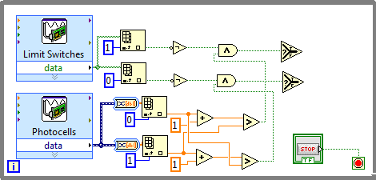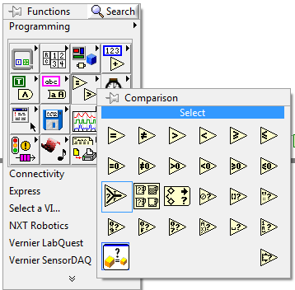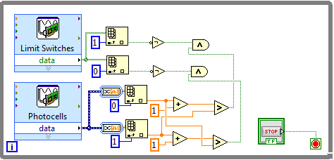

**Create a Select Block**

**Go to Comparison from block diagram Functions pallet.**

**Create two Select blocks and connect them to the And blocks**

**Connect the Greater? And Not blocks to the And block as shown**

**Create two Not blocks and two And blocks.**

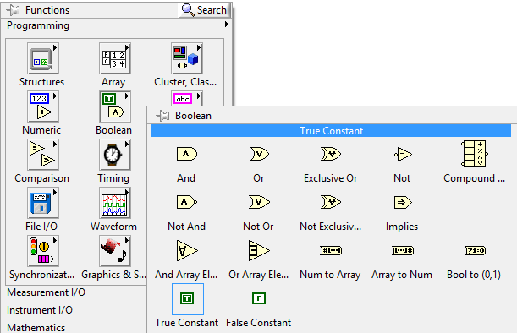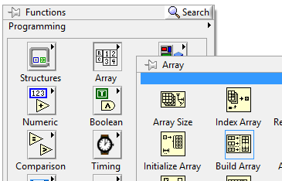

**Create a False Constant**

**Create a True Constant**

**Go to Boolean from the Functions pallet**

**Create a Build Array**

**From the Functions pallet, go to Array**

**Expand the size of Build Array from its bottom border to create another array element**

**Note: It’s a best guess that True Constant will give the direction that turns right. You must test this for yourself and decided whether to use a True Constant or a False Constant.**

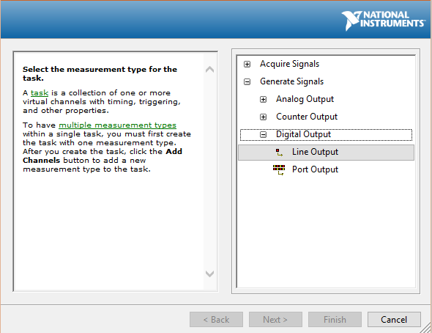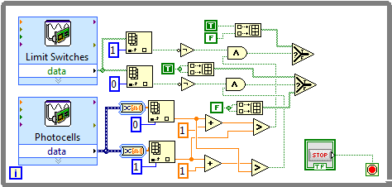

**Select Line Output**

**From the DAQ Assistant window, choose Generate Signals**

**Choose Digital Output**

**Create another DAQ Assistant from the Functions pallet.**

**Connect the True/False Constants to the Build Arrays and connect the Build Arrays to the terminals of the Select blocks as shown**

**Create three Build Arrays and four True/False Constants.**

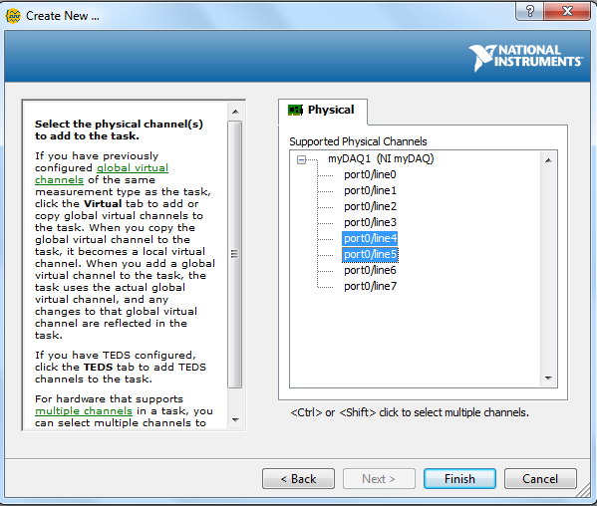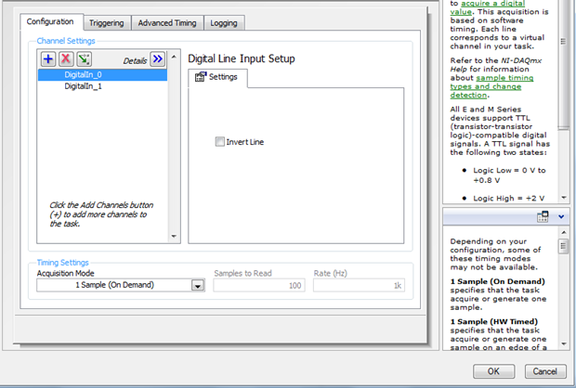

**Select Ports 4 and 5 using the Ctrl Key**

**Leave settings on next window as default and press OK**

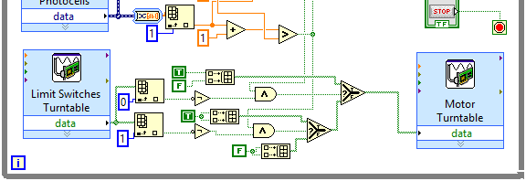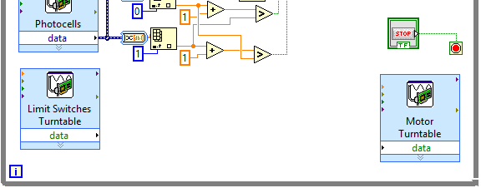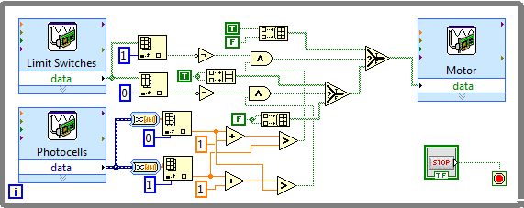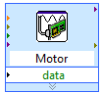

**Set up the connections between the new DAQ Assistants in the same way as the other Limit Switch and Motor.**

**Create another DAQ Assistant to generate digital output to ports 6 and 7 for the Turntable Motor**

**Create a DAQ Assistant to acquire digital input from ports 2 and 3 for the Limit Switches of the Turntable**

**Connect the Select Block to the Motor DAQ Assistant**

**Connect the two Select Blocks as shown**

**Rename the DAQ Assistant to specify its purpose**

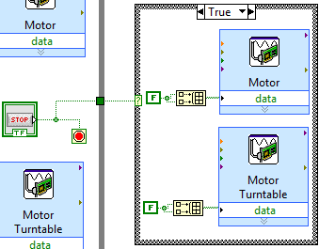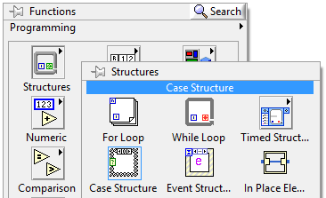

**Select Case Structure**

**Open Structures from the Functions pallet**

**Congratulations, your LabView VI is now complete. You may wish to add comments to specific portions of your program so that others can more easily understand it. You can do this by double-clicking at an empty space on the block diagram.**

**Place the Case Structure outside the While Loop. Set it up as shown in this diagram.**

**Connect the Case Structure to the Stop Button Control**

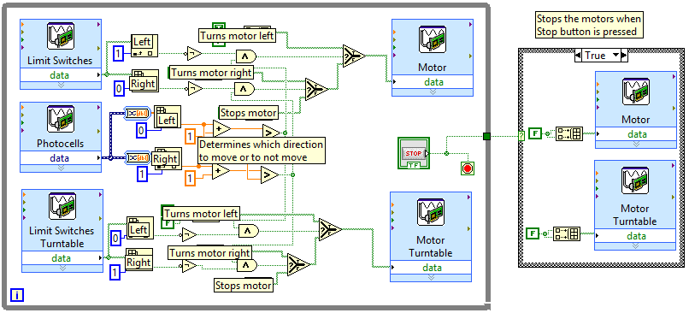

|  |
| --- |
| Present |

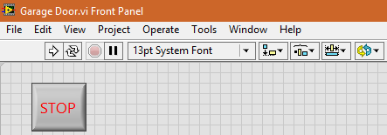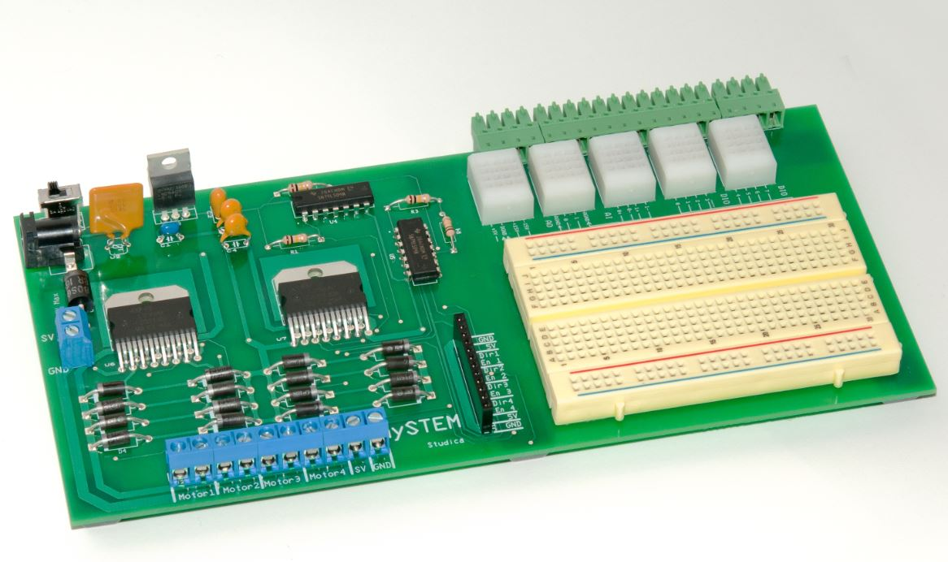

**Press the Stop Button on the front panel after you are done**

**Test your final system before showing it for evaluation. Make sure it works as you would expect. If you find something wrong, refer back to the steps in this tutorial and see if you followed them properly.**

**Make sure it is connected to an external power source**

**Make sure your mySTEM board is turned ON**

**Click the Run button on the toolbar to start the program**